Eileen Spencer

Fundamentals of Machine Learning (MIS 64060-001)

Final Exam (Paper)

May 24, 2022

**FINAL EXAM PAPER**

**OBJECTIVE:**

Some in the higher education field may wonder how a student’s IQ rating impacts or determines their performance in school. I have done some research and data analytics to study just that on a small sample of 200 final-year students cumulative GPA and their IQ scores. While smart students are usually expected to do well in school, sometimes outside circumstances can impact their learning. This is an important thing to consider, however this analysis was done in a big picture way, to see the general correlation between a student’s IQ and their cumulative GPA.

**APPROACH:**

My real data was sourced from Kaggle.com and contained both the IQ scores and cumulative GPA of 200 students. The description of this dataset said to include the information of final year college students. “This dataset defines the CGPA variable as “CGPA stands for Cumulative grade points average and is the average of grade points obtained in all the subjects” and the IQ variable as “An intelligence quotient is a total score derived from a set of standardized tests or subtests designed to assess human intelligence” (College Student Data).

In order for me to understand this data, I did some preliminary research to understand the brackets that IQ’s are usually measured in. According to verywellmind.com, there are generally 4 IQ brackets ranging from average intelligence to highly gifted. Average intelligence is scores from 85-114, Above Average intelligence are scores from 115-129, Moderately gifted scores range from 130-144, and highly gifted scores are 145-159 (Do You Have…). Using this scale, I wanted to look at how many students with above average or higher IQ scores and the correlation to their cumulative GPA. I decided to go for above average CGPAs for my analysis as well, which turned out to be 6.98.

**ANALYSIS:**

After my analysis, here are some of the conclusions I found:

* Of the 200 students in the dataset, 43 (21.5%) were reported to having above average IQs, or a score of 115 and over.
* Of the 200 students in the dataset, 57 (21.5%) were reported to have a higher-than-average CGPA, or 6.98 and above.
* Of the 200 students in the dataset, 86 (43%) students had both an above average IQ and an above average CGPA.
* This is all summarized in the graph below:

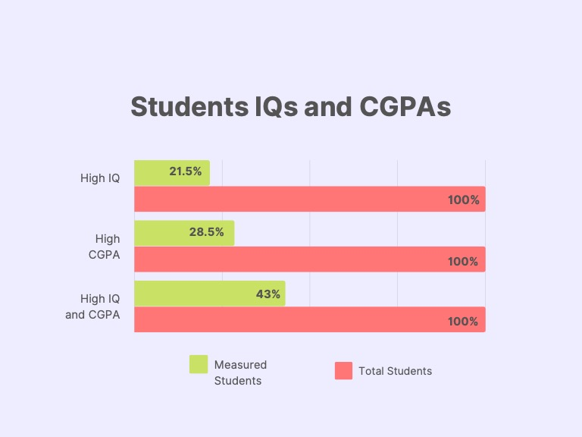

**CONCLUSIONS:**

The findings from this analysis show that less than half the students with higher-than-normal IQs had higher than normal CGPAs. More research would need to be done in this sector to tell us more, however this is a good idea as to how external factors can impact the performance of students in higher education. This information would be very helpful to universities and schools across the country to prove how important other dynamics in a student’s life can impact their ability to learn and focus.

**RESOURCES:**

#### "College Student Data". *Kaggle.Com*, 2022, https://www.kaggle.com/datasets/kuchhbhi/cpga-iq-placement. Accessed 5 May 2022.

#### "Do You Have A Genius IQ Score?". *Verywell Mind*, 2022, https://www.verywellmind.com/what-is-a-genius-iq-score-2795585. Accessed 5 May 2022.